Hedgehog Class Weekly Update Week Beg: 23rd January

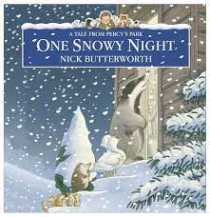
Language and Literacy
‘One Snowy Night’ has been retold many times and inspired some great role play in our own Percy’s Hut in class. Reception have been talking and writing about where the animals hid and slept. Year 1 have been looking closely at adjectives (describing words), finding answers to questions and telling the story from an animal’s point of view. Here is a version to watch: https://www.youtube.com/watch?v=HYlWg-15U9A

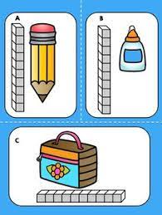
Maths
We have all been learning about Measurement this week. All children were able to compare the length or height of different objects and say which was the longest/tallest or shortest. Reception made dough snakes, train tracks and sorted/drew snow-families! Year 1 used multi-link cubes to measure different objects in the classroom and were able to estimate the length or height of some. They were introduced to using 1 metre as a unit of measurement.

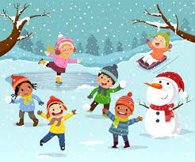
Science
As the cold weather continues, the outdoor areas have offered more opportunities to investigate – wondering why the salty grit melts the ice led to an experiment involving sprinkling different things onto blocks of ice. Groups of children tried salt, sugar, glitter, flour, oil and coffee. Can the children remember what happened overnight? The interest and thoughtful explanations were fantastic – well done Hedgehogs! Geography, including locating some VERY cold places in our world, is coming soon…

RE | PE | Music
We have started a unit of work about Creation.  We read a beautiful retelling of the Creation Story found in the Bible and had a time of reflecting on the wonder of this. | We did a Dance session inspired by Ice Dancing; exploring the shapes, balances and travel directions we saw on videos.  Please note:  ALL of Hedgehog Class will now do PE on THURSDAYS, please send your child in suitable sports clothing. | Reception have been exploring loud/quiet sounds, copying musical patterns and following the beat to songs using percussion instruments.  Year 1 have developed their singing skills with Ms McKee.

Please also note that ALL of Hedgehog Class now do FOREST SCHOOL on FRIDAYS
Next Week’s Learning:
Language/Literacy: Reading and Writing activities based on Lost and Found by Oliver Jeffers
and The Emporer’s Egg by Martin Jenkins
Phonics: Year 1 – Revising and using Phase 3 trigraphs ear / air / ure / er
Reception – Continuing Phase 3 single sounds w / x / y / z / qu
Maths: Year 1 – Using numbers to 20, introducing place value (understanding 10s and 1s)
Reception - Using numbers, matching and comparing amounts up to 10
Geography – Locating Polar regions of the world, comparing to the UK
Science – Learning about Penguins – how they look, feed, move, lay eggs and survive

