Hedgehog Class Weekly Update Week Beg: 24th April

Coronation Celebration Lunch: Thursday 4th May. Wear red, white & blue!
From next week Forest School is on Wednesday afternoons for Hedgehog class.

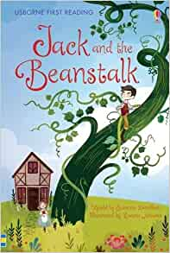
Language and Literacy
We have continued our short unit on the traditional tale of Jack and the Beanstalk. Having ordered pictures to create story maps showing the events, we used these to retell with actions and adding interesting vocabulary. Then Year 1 wrote the story themselves, taking care with the punctuation and spelling. Reception chose one or two events to write sentences about, using their phonic skills and tricky word recognition to spell the words. Mrs Prior was very impressed with our hard work and super writing as she passed through our classroom.

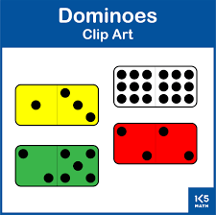
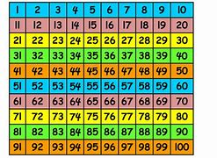
Maths
Year 1 continue using 2 digit numbers on a hundred square. They worked on various calculations including money problems by counting forward and backward in multiples of 10. Reception have been practising reading and writing numbers up to 20, and also finding the total of two or more sets of objects. They used dominoes to find different groups of spots that made 10 altogether.
Art & Design
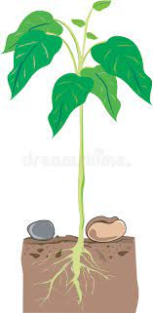
We continue our Once Upon a Time theme by continuing to build and furnish our role play castle area in the classroom. With the Kings coronation celebrations approaching next week, we have begun paper chains and bunting to decorate our classroom and the hall for the Celebration lunch on Thursday!
Science
Our outdoor learning this week included planting bean seeds. We thought about what conditions plants need to grow and stay healthy, and predicted how long it might take to see shoots and grow vegetables. Now we must take of them and wait and see what happens…
RE | Music & Dance
Following on from the Easter story, we considered Jesus as a leader and people who followed him.  We also talked about leaders we know in our own community. | We are learning traditional folk dances to perform at the May Fair. Working with partners and remembering different movement sequences is great for physical and brain development!
Next Week
Literacy/Language Reading and writing about King Charles
Phonics Year 1: Revise Phase 5 split digraphs a_e / o_e / i_e / e_e / u_e
Reception: Revise Phase 3 consonant diagraphs ai / ee / oa / igh
Maths Year 1: Count in 10s on 100 square, adding on in 10s
Reception: Revise numbers to 20, Practical subtraction activities
Art / Design Making objects for castle life and Royal Celebrations
History Learning about the life of King Charles and the Royal Family

