Hedgehog Class Weekly Update Week Beg: 24th February

Thank you to all of families who came to Parent’s Evenings – it was great to talk and share the children’s progress with you.
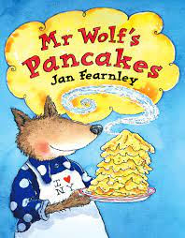
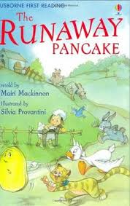
Language and Literacy
As Pancake Day was on Tuesday, we used the opportunity to use our language and literacy skills for food based tasks. After watching a video of children making pancakes, we all wrote shopping lists using our phonic skills. Reception then sequenced pictures and described what happened in each step. Year 1 were challenged to write the whole recipe involving lists of ingredients and equipment, before writing instructions in order.We also read stories on this theme. Firstly, The Runaway Pancake (a traditional tale) and then Mr Wolf’s Pancakes by Jan Fearnley – a funny story with a surprise ending!

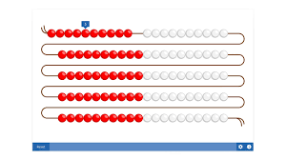
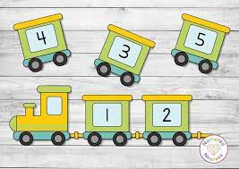
Maths
The challenge of 2 digit continues for Year 1. We have moved to using numbers to 100 with Tens and Ones, by using sticks of cubes and bead strings, and even metre rulers. Reception keep practising reading and ordering the numbers to 10, as well as carefully counting the sets of objects to go with them. They have begun working on finding 1 more than another number in a group of objects and in a row of numbers.
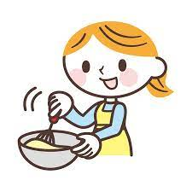
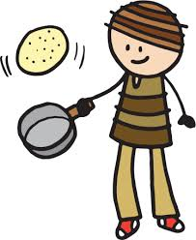
Design Technology (food) / Physical Development
After spending time talking, reading and writing about pancakes, on Friday we made and ate some ourselves. Following the recipes we made, we carefully meausured ingredients, mixed them up and were able to eat them once adults cooked them. Finally we tried flipping them in cooler pans – some of us landed them safely in the pan, but others flipped right out. A lovely way to end our week!

RE | PE | Music
In our Collective Worship in class and as a school, we learnt that Shrove Tuesday (Pancake Day) and Ash Wednesday mark the beginning of Lent.  We read a Bible story about the time Jesus spent in the desert and was tempted, which is what inspires the tradition of fasting in Lent. | We did a Dance session based on being Jungle Explorers.  We experimented with lots of different ways to travel as we pretended to be lots of animals.  Please note:  ALL of Hedgehog Class will now do PE on THURSDAYS, please send your child in suitable sports clothing. | Reception sang some simple songs about food and pancakes. We enjoyed making up our own ‘Flip, flip Hooray’ song on Friday.  Year 1 have developed their singing skills with Ms McKee, focussing on a different speech sound each week. They used percussion instruments this week to.
Please also note that ALL of Hedgehog Class now do FOREST SCHOOL on FRIDAYS
Next Week
Literacy/Language Activities based on Sleeping Beauty
Phonics Year 1: Phase 5 digraphs ay / ou / ie / ea
Reception: Phase 3 digraphs sh / ch / th / ng
Maths Year 1: Place Value in numbers to 100 (Tens and Ones)
Reception: Comparing Numbers to 10 (higher/lower, more/less)
Science / D.T. Exploring spinning, wool and weaving
Investigating / building castles

