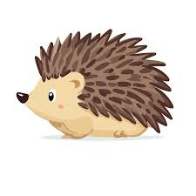
Hedgehog Class Update Week Beg: 7 / 10 / 24
In school we have been focusing on:
Personal, Social & Emotional Development | Play with one or more other children, extending and elaborating play ideas.  Take part in pretend play.
Communication & Language (Speaking & Listening) | Learn new vocabulary  Speak & listen in group tasks  Offer explanations about what happens
Physical Development | Uses one handed tools and equipment.  Use comfortable grip with good control.  Writing Tasks and Using Kitchen Tools
Literacy: Phonics  Drawing Club | i n m d (previous week: s a t p)  The Enormous Turnip – Traditional Tale
Mathematics | Make comparisons between objects relating to  size, capacity and weight.  Practical Measurement Tasks
Understanding the World  (Science/History/Geography) | Use senses to explore processes and changes in the world around us (inc similarities/differences).  Cooking and Making Soup
Expressive & Artistic Design (Art/Music/Pretend Play) | Invent, adapt and recount stories  Safely use materials, tools and techniques  Child Led learning
Please log in to Seesaw to see group and individual learning photos and observations.
At home, please work with your child on the following:
Reading  (at least 3 times a week) | Read the wordless books, discussing each page in detail. Encourage full sentence responses by modelling this verbally.
Phonics  (at least 3 times a week) | Practise the sounds we have learnt:  Say the sound when shown the letter  Play I-Hear and I-Spy games
Writing | Practice name writing using the correct formation for each letter  Practise the correct formation for the sounds learnt in phonics
Maths | Compare the size, weight and capacity of different objects around the room
Extra Challenge | Cook a simple recipe together!  OR  Shop for and try some new vegetables or fruits

