Relationship and Sex Education policy
2023



Whaddon C of E School

Approved by: | Whaddon School Governing board | Date: September 2023
Last reviewed on: | September 2023
Next review due by: | September 2026
Contents
1. Aims 3
2. Statutory requirements 3
3. Policy development 5
4. Definition 5
5. Curriculum 5
6. Delivery of RSE 6
7. Use of external organisations and materials 7
8. Roles and responsibilities 8
9. Parents’ right to withdraw 9
10. Training 10
11. Monitoring arrangements 10
Appendix 1: Curriculum map 11
Appendix 2: By the end of primary school pupils should know 12
Appendix 2: By the end of secondary school pupils should know 14
Appendix 3: Parent form: withdrawal from sex education within RSE 17

1. Aims
The aims of relationships and sex education (RSE) at our school are to:
- Provide a framework in which sensitive discussions can take place
- Prepare pupils for puberty, and give them an understanding of sexual development and the importance of health and hygiene
- Help pupils develop feelings of self-respect, confidence and empathy
- Create a positive culture around issues of sexuality and relationships
- Teach pupils the correct vocabulary to describe themselves and their bodies
RSE at Whaddon School is the cornerstone of our commitment to ensure that our children have awareness and skills of how to develop and maintain healthy minds, bodies and relationships; throughout their lives. Respect for self, others and fostering an inclusive and celebratory awareness of diversity and personal identity will help prepare our pupils for life in 21st Century Britain and well rounded global citizens with open minds and hearts.

2. Statutory requirements
As a maintained primary school, we must provide relationships education to all pupils under section 34 of the Children and Social Work Act 2017.
We are not required to provide sex education, but we do need to teach the elements of sex education contained in the science curriculum.
In teaching RSE, we must have regard to guidance issued by the secretary of state, as outlined in section 403 of the Education Act 1996.
We must also have regard to our legal duties set out in:
- Sections 406 and 407 of the Education Act 1996
- Part 6, chapter 1 of the Equality Act 2010
- The Public Sector Equality Duty (as set out in section 149 of the Equality Act 2010). This duty requires public bodies to have due regard to the need to eliminate discrimination, advance equality of opportunity and foster good relations between different people when carrying out their activities
At Whaddon C of E School we teach RSE as set out in this policy.

- The Public Sector Equality Duty (as set out in section 149 of the Equality Act 2010). This duty requires public bodies to have due regard to the need to eliminate discrimination, advance equality of opportunity and foster good relations between different people when carrying out their activities

3. Policy development
This policy has been developed in consultation with staff, pupils and parents. The consultation and policy development process involved the following steps:
- Review – a member of staff or working group pulled together all relevant information including relevant national and local guidance

- Staff consultation – all school staff were given the opportunity to look at the policy and make recommendations

- Parent/stakeholder consultation – parents and any interested parties were invited to attend a meeting about the policy

- Pupil consultation – we investigated what exactly pupils want from their RSE

- Ratification – once amendments were made, the policy was shared with governors and ratified

4. Definition
RSE is about the emotional, social and cultural development of pupils, and involves learning about relationships, sexual health, sexuality, healthy lifestyles, diversity and personal identity.
RSE involves a combination of sharing information, and exploring issues and values.
RSE is not about the promotion of sexual activity.

5. Curriculum
Our RSE curriculum is set out as per Appendix 1, but we may need to adapt it as and when necessary.
We have developed the curriculum in consultation with parents, pupils and staff, and taking into account the age, developmental stage, needs and feelings of our pupils. If pupils ask questions outside the scope of this policy, teachers will respond in an appropriate manner so that pupils are fully informed and don’t seek answers online.
Primary sex education will focus on:
- Preparing boys and girls for the changes that adolescence brings
- How a baby is conceived and born
For more information about our curriculum, see our curriculum map in Appendix 1.

6. Delivery of RSE
individual approach to delivering RSE
- At Whaddon C of E School we will teach our RSE related topics within the key skills and knowledge for the age and aptitude of the children- through a range of forum style conversations, practical activities and in a cross-curricular way as far as possible, so as not to dilute or detract from the fidelity of the content of the RSE curriculum. Year 6 sex education will be taught by teachers who have received appropriate training and health care professionals.
- It is imperative that we empower our pupils with an ability to advocate for themselves and recognise potential “threats” without creating a sense of fear or suspicion they are too young/inexperienced to process, or which hinders their enjoyment of life. It is important that children have a voice and can articulate their thoughts, concerns and questions to help keep themselves, healthy, safe, respectful and to make sense of the world around them and their personal and sexual identity.
- Reasonable adjustments and adaptations to materials and how subjects are taught will be factored into planning a lessons and resources will be matched to the aptitude of the individual child. EAL children will have resources in their first language.
- RSE is taught within the personal, social, health and economic (PSHE) education curriculum. Biological aspects of RSE are taught within the science curriculum, and other aspects are included in religious education (RE).

Relationships education focuses on teaching the fundamental building blocks and characteristics of positive relationships including:
- Families and people who care for me
- Caring friendships
- Respectful relationships
- Online relationships
- Being safe
Alongside this, is our sex education that we provide in year 6 which is covered through Science- reproduction unit. In year 5, we cover puberty and changes, but do not make reference to intercourse or reproduction.
For more information about our RSE curriculum, see Appendices 1 and 2.

These areas of learning are taught within the context of family life, taking care to make sure that there is no stigmatisation of children based on their home circumstances (families can include single parent families, LGBT parents, families headed by grandparents, adoptive parents and foster parents/carers, amongst other structures), along with reflecting sensitively that some children may have a different structure of support around them (for example, looked-after children or young carers).
We will also be mindful of the law and legal requirements, taking care not to condone or encourage illegal political activity, such as violent action against people, criminal damage to property, hate crime, terrorism or the illegal use of drugs.

  - Inclusivity
We will teach about these topics in a manner that:
- Considers how a diverse range of pupils will relate to them
- Is sensitive to all pupils’ experiences
- During lessons, makes pupils feel:
  - Safe and supported
  - Able to engage with the key messages
We will also:
- Make sure that pupils learn about these topics in an environment that’s appropriate for them, for example in:
  - A whole-class setting
  - Small groups or targeted sessions
  - 1-to-1 discussions
  - Digital formats
- Give careful consideration to the level of differentiation needed

  - Use of resources
We will consider whether any resources we plan to use:
  - Are aligned with the teaching requirements set out in the statutory RSE guidance
  - Would support pupils in applying their knowledge in different contexts and settings
  - Are age-appropriate, given the age, developmental stage and background of our pupils
  - Are evidence-based and contain robust facts and statistics
  - Fit into our curriculum plan
  - Are from credible sources
  - Are compatible with effective teaching approaches
  - Are sensitive to pupils’ experiences and won’t provoke distress

7. Use of external organisations and materials
We will make sure that an agency and any materials used are appropriate and in line with our legal duties around political impartiality.
The school remains responsible for what is said to pupils. This includes making sure that any speakers, tools and resources used don’t undermine the fundamental British values of democracy, the rule of law, individual liberty, and mutual respect and tolerance of those with different faiths and beliefs.
We will:
- Make appropriate checks and engage with external agencies to make sure that their approach to teaching about RSE is balanced, and it and the resources they intend to use:
  - Are age-appropriate
  - Are in line with pupils’ developmental stage
  - Comply with:
    - This policy
    - The Teachers’ Standards
    - The Equality Act 2010
    - The Human Rights Act 1998
    - The Education Act 1996
- Only work with external agencies where we have full confidence in the agency, its approach and the resources it uses
- Make sure that any speakers and resources meet the intended outcome of the relevant part of the curriculum
- Review any case study materials and look for feedback from other people the agency has worked with
- Be clear on:
  - What they’re going to say
  - Their position on the issues to be discussed
- Ask to see in advance any materials that the agency may use
- Know the named individuals who will be there, and follow our usual safeguarding procedures for these people
- Conduct a basic online search and address anything that may be of concern to us, or to parents and carers
- Check the agency’s protocol for taking pictures or using any personal data they might get from a session
- Remind teachers that they can say “no” or, in extreme cases, stop a session
- Make sure that the teacher is in the room during any sessions with external speakers
We won’t, under any circumstances:
- Work with external agencies that take or promote extreme political positions
- Use materials produced by such agencies, even if the material itself is not extreme

8. Roles and responsibilities
8.1 The governing board
The governing board has delegated the approval of this policy to Mrs Prior, headteacher.
8.2 The headteacher
The headteacher is responsible for ensuring that RSE is taught consistently across the school, and for managing requests to withdraw pupils from non-statutory components of RSE (see section 9).
8.3 Staff
Staff are responsible for:
- Delivering RSE in a sensitive way
- Modelling positive attitudes to RSE
- Monitoring progress
- Responding to the needs of individual pupils
- Responding appropriately to pupils whose parents wish them to be withdrawn from the [non-statutory components of RSE
Staff do not have the right to opt out of teaching RSE. Staff who have concerns about teaching RSE are encouraged to discuss this with the headteacher.
Teachers who will deliver the curriculum elements are the year 5/6 teacher Mr. Small and the Headteacher Mrs Prior. A school nurse may be asked to come in to deliver some of the curriculum coverage.

8.4 Pupils
Pupils are expected to engage fully in RSE and, when discussing issues related to RSE, treat others with respect and sensitivity.

9. Parents’ right to withdraw
Parents do not have the right to withdraw their children from relationships education.
Parents have the right to withdraw their children from the non-statutory components of sex education within RSE.
Requests for withdrawal should be put in writing using the form found in Appendix 3 of this policy and addressed to the headteacher.
Alternative school work will be given to pupils who are withdrawn from sex education.

10. Training
Staff are trained on the delivery of RSE as part of their induction and it is included in our continuing professional development calendar.
The headteacher will also invite visitors from outside the school, such as school nurses or sexual health professionals, to provide support and training to staff teaching RSE.

11. Monitoring arrangements
The delivery of RSE is monitored by Mrs Marchant PSHE subject leader through:
Learning walks, book looks, lesson observations and planning skills mapping and coverage progression monitoring.
Pupils’ development in RSE is monitored by class teachers as part of our internal assessment systems.
This policy will be reviewed by Chair of Governors- Amanda Hardman, headteacher Sarah Prior, annually or when revisions are released as statutory reviews. At every review, the policy will be approved by the governing board curriculum and pupil welfare committee Amanda Hardman and Sarah Prior the headteacher.

PSHE association and other external curriculum links
https://pshe-association.org.uk/resource/programme-of-study-ks1-5

https://fs.hubspotusercontent00.net/hubfs/20248256/Programme%20of%20Study/PSHE%20Association%20Programme%20of%20Study%20for%20PSHE%20Education%20(Key%20stages%201%E2%80%935)%2c%20Jan%202020.pdf?hsCtaTracking=d718fa8f-77a8-445b-a64e-bb10ca9a52d8%7C90ef65f6-90ab-4e84-af7b-92884c142b27

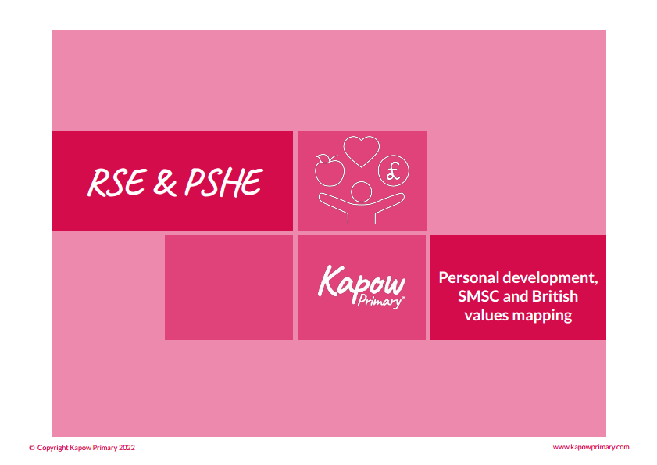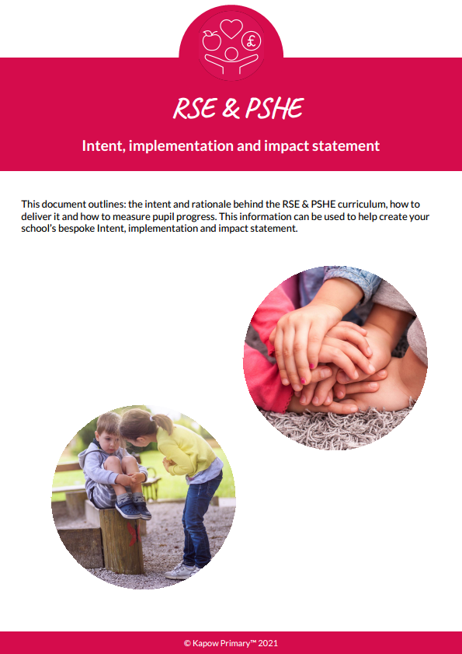

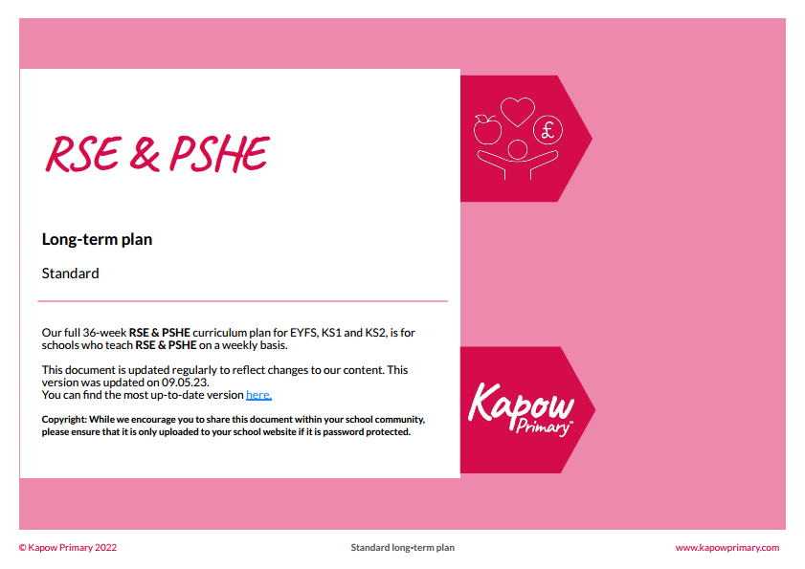
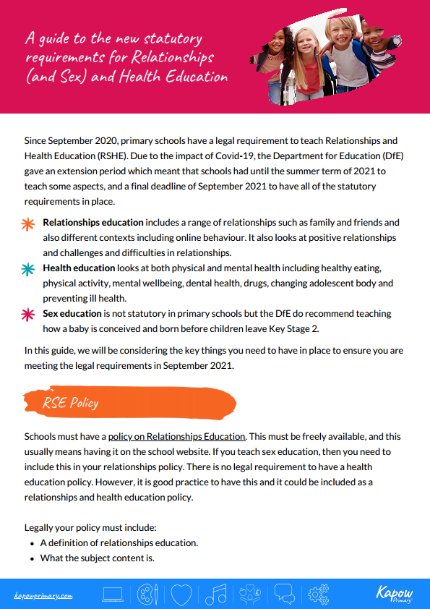

Other resources used in year 5
- Newsround- let’s talk about periods
- Operation ouch BBCteach
- How and why to teach period education Twinkl
- The human species Hamilton Brookes

Appendix 2: By the end of primary school pupils should know
Topic | Pupils should know
Families and people who care about me | - That families are important for children growing up because they can give love, security and stability  - The characteristics of healthy family life, commitment to each other, including in times of difficulty, protection and care for children and other family members, the importance of spending time together and sharing each other’s lives  - That others’ families, either in school or in the wider world, sometimes look different from their family, but that they should respect those differences and know that other children’s families are also characterised by love and care  - That stable, caring relationships, which may be of different types, are at the heart of happy families, and are important for children’s security as they grow up  - That marriage represents a formal and legally recognised commitment of two people to each other which is intended to be lifelong  - How to recognise if family relationships are making them feel unhappy or unsafe, and how to seek help or advice from others if needed
Caring friendships | - How important friendships are in making us feel happy and secure, and how people choose and make friends  - The characteristics of friendships, including mutual respect, truthfulness, trustworthiness, loyalty, kindness, generosity, trust, sharing interests and experiences and support with problems and difficulties  - That healthy friendships are positive and welcoming towards others, and do not make others feel lonely or excluded  - That most friendships have ups and downs, and that these can often be worked through so that the friendship is repaired or even strengthened, and that resorting to violence is never right  - How to recognise who to trust and who not to trust, how to judge when a friendship is making them feel unhappy or uncomfortable, managing conflict, how to manage these situations and how to seek help or advice from others, if needed
Respectful relationships | - The importance of respecting others, even when they are very different from them (for example, physically, in character, personality or backgrounds), or make different choices or have different preferences or beliefs  - Practical steps they can take in a range of different contexts to improve or support respectful relationships  - The conventions of courtesy and manners  - The importance of self-respect and how this links to their own happiness  - That in school and in wider society they can expect to be treated with respect by others, and that in turn they should show due respect to others, including those in positions of authority  - About different types of bullying (including cyberbullying), the impact of bullying, responsibilities of bystanders (primarily reporting bullying to an adult) and how to get help  - What a stereotype is, and how stereotypes can be unfair, negative or destructive  - The importance of permission-seeking and giving in relationships with friends, peers and adults
Online relationships | - That people sometimes behave differently online, including by pretending to be someone they are not  - That the same principles apply to online relationships as to face-to face relationships, including the importance of respect for others online including when we are anonymous  - The rules and principles for keeping safe online, how to recognise risks, harmful content and contact, and how to report them  - How to critically consider their online friendships and sources of information including awareness of the risks associated with people they have never met  - How information and data is shared and used online
Being safe | - What sorts of boundaries are appropriate in friendships with peers and others (including in a digital context)  - About the concept of privacy and the implications of it for both children and adults; including that it is not always right to keep secrets if they relate to being safe  - That each person’s body belongs to them, and the differences between appropriate and inappropriate or unsafe physical, and other, contact  - How to respond safely and appropriately to adults they may encounter (in all contexts, including online) whom they do not know  - How to recognise and report feelings of being unsafe or feeling bad about any adult  - How to ask for advice or help for themselves or others, and to keep trying until they are heard  - How to report concerns or abuse, and the vocabulary and confidence needed to do so  - Where to get advice e.g. family, school and/or other sources

Appendix 3: Parent form: withdrawal from sex education within RSE

To be completed by parents
Name of child |  | Class
Name of parent |  | Date
Reason for withdrawing from sex education within relationships and sex education
Any other information you would like the school to consider
Parent signature

To be completed by the school
Agreed actions from discussion with parents

