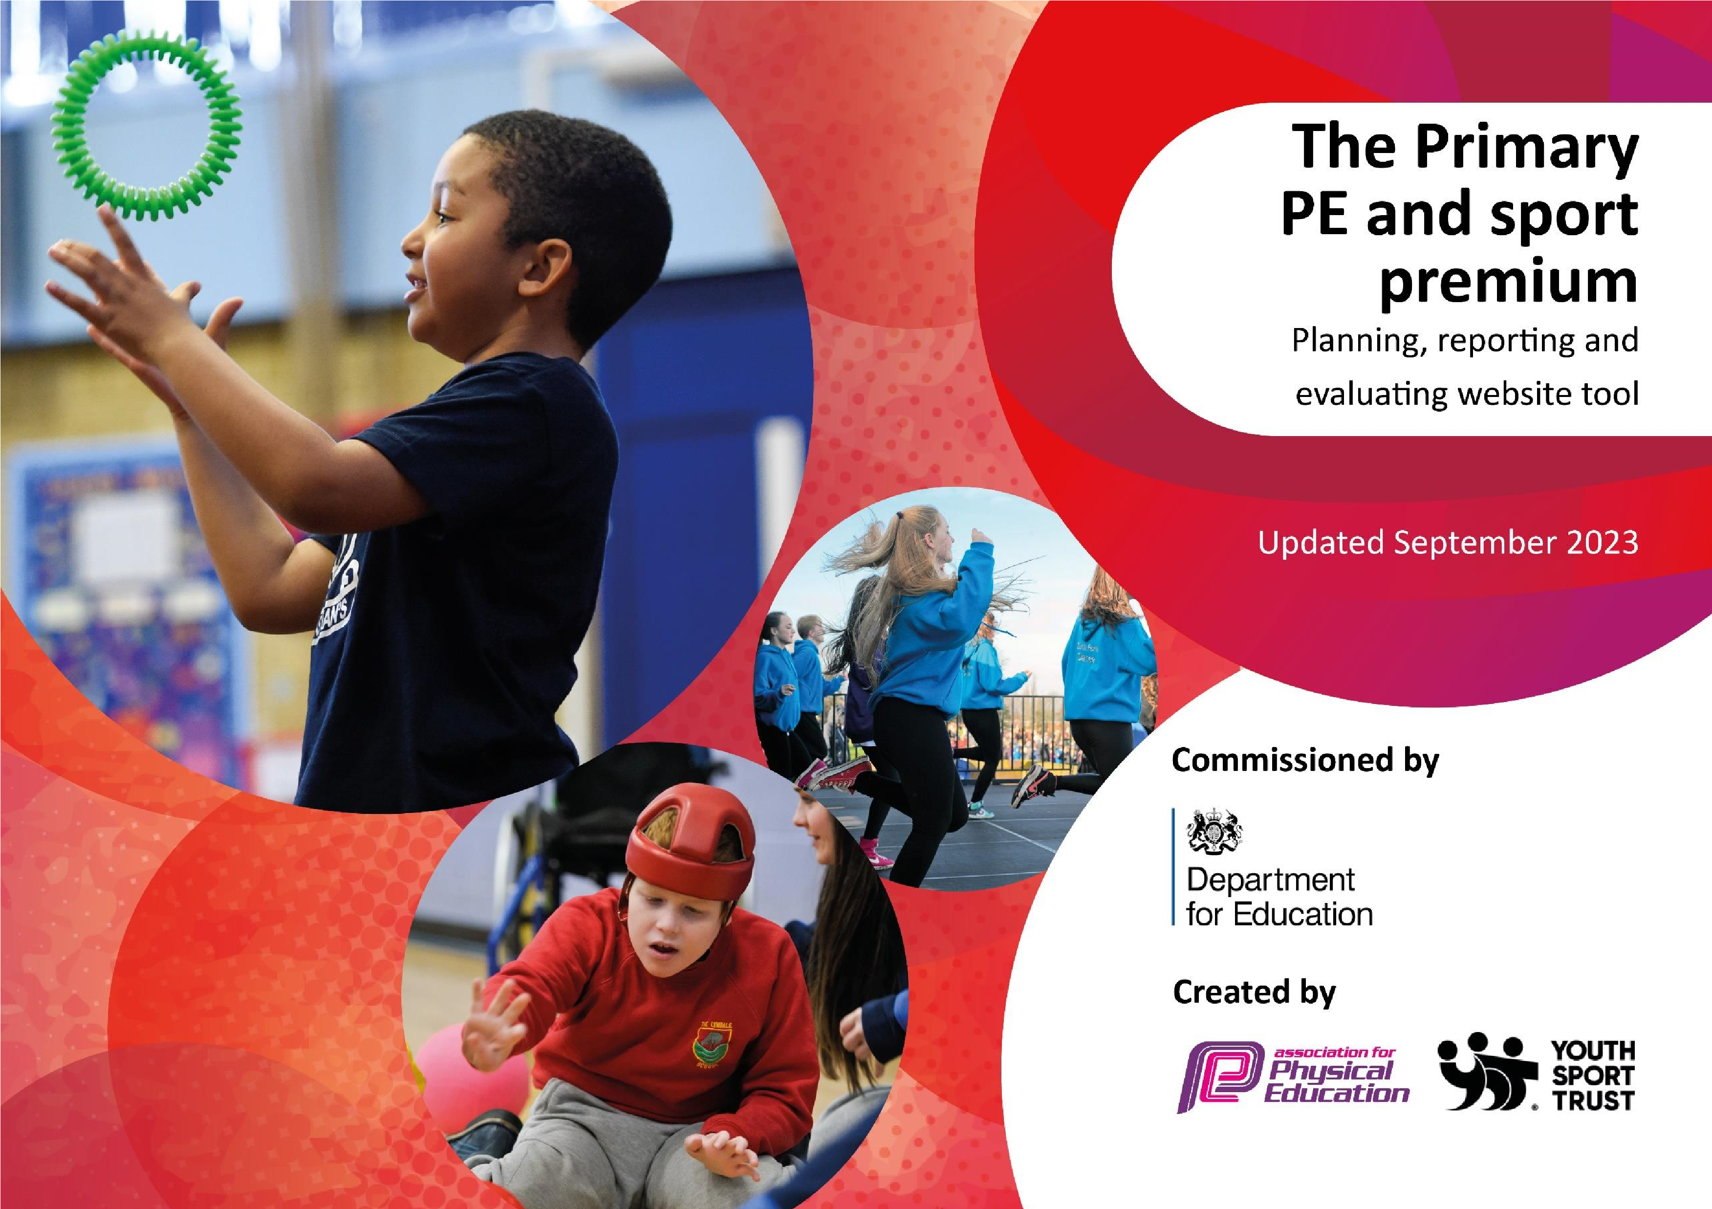

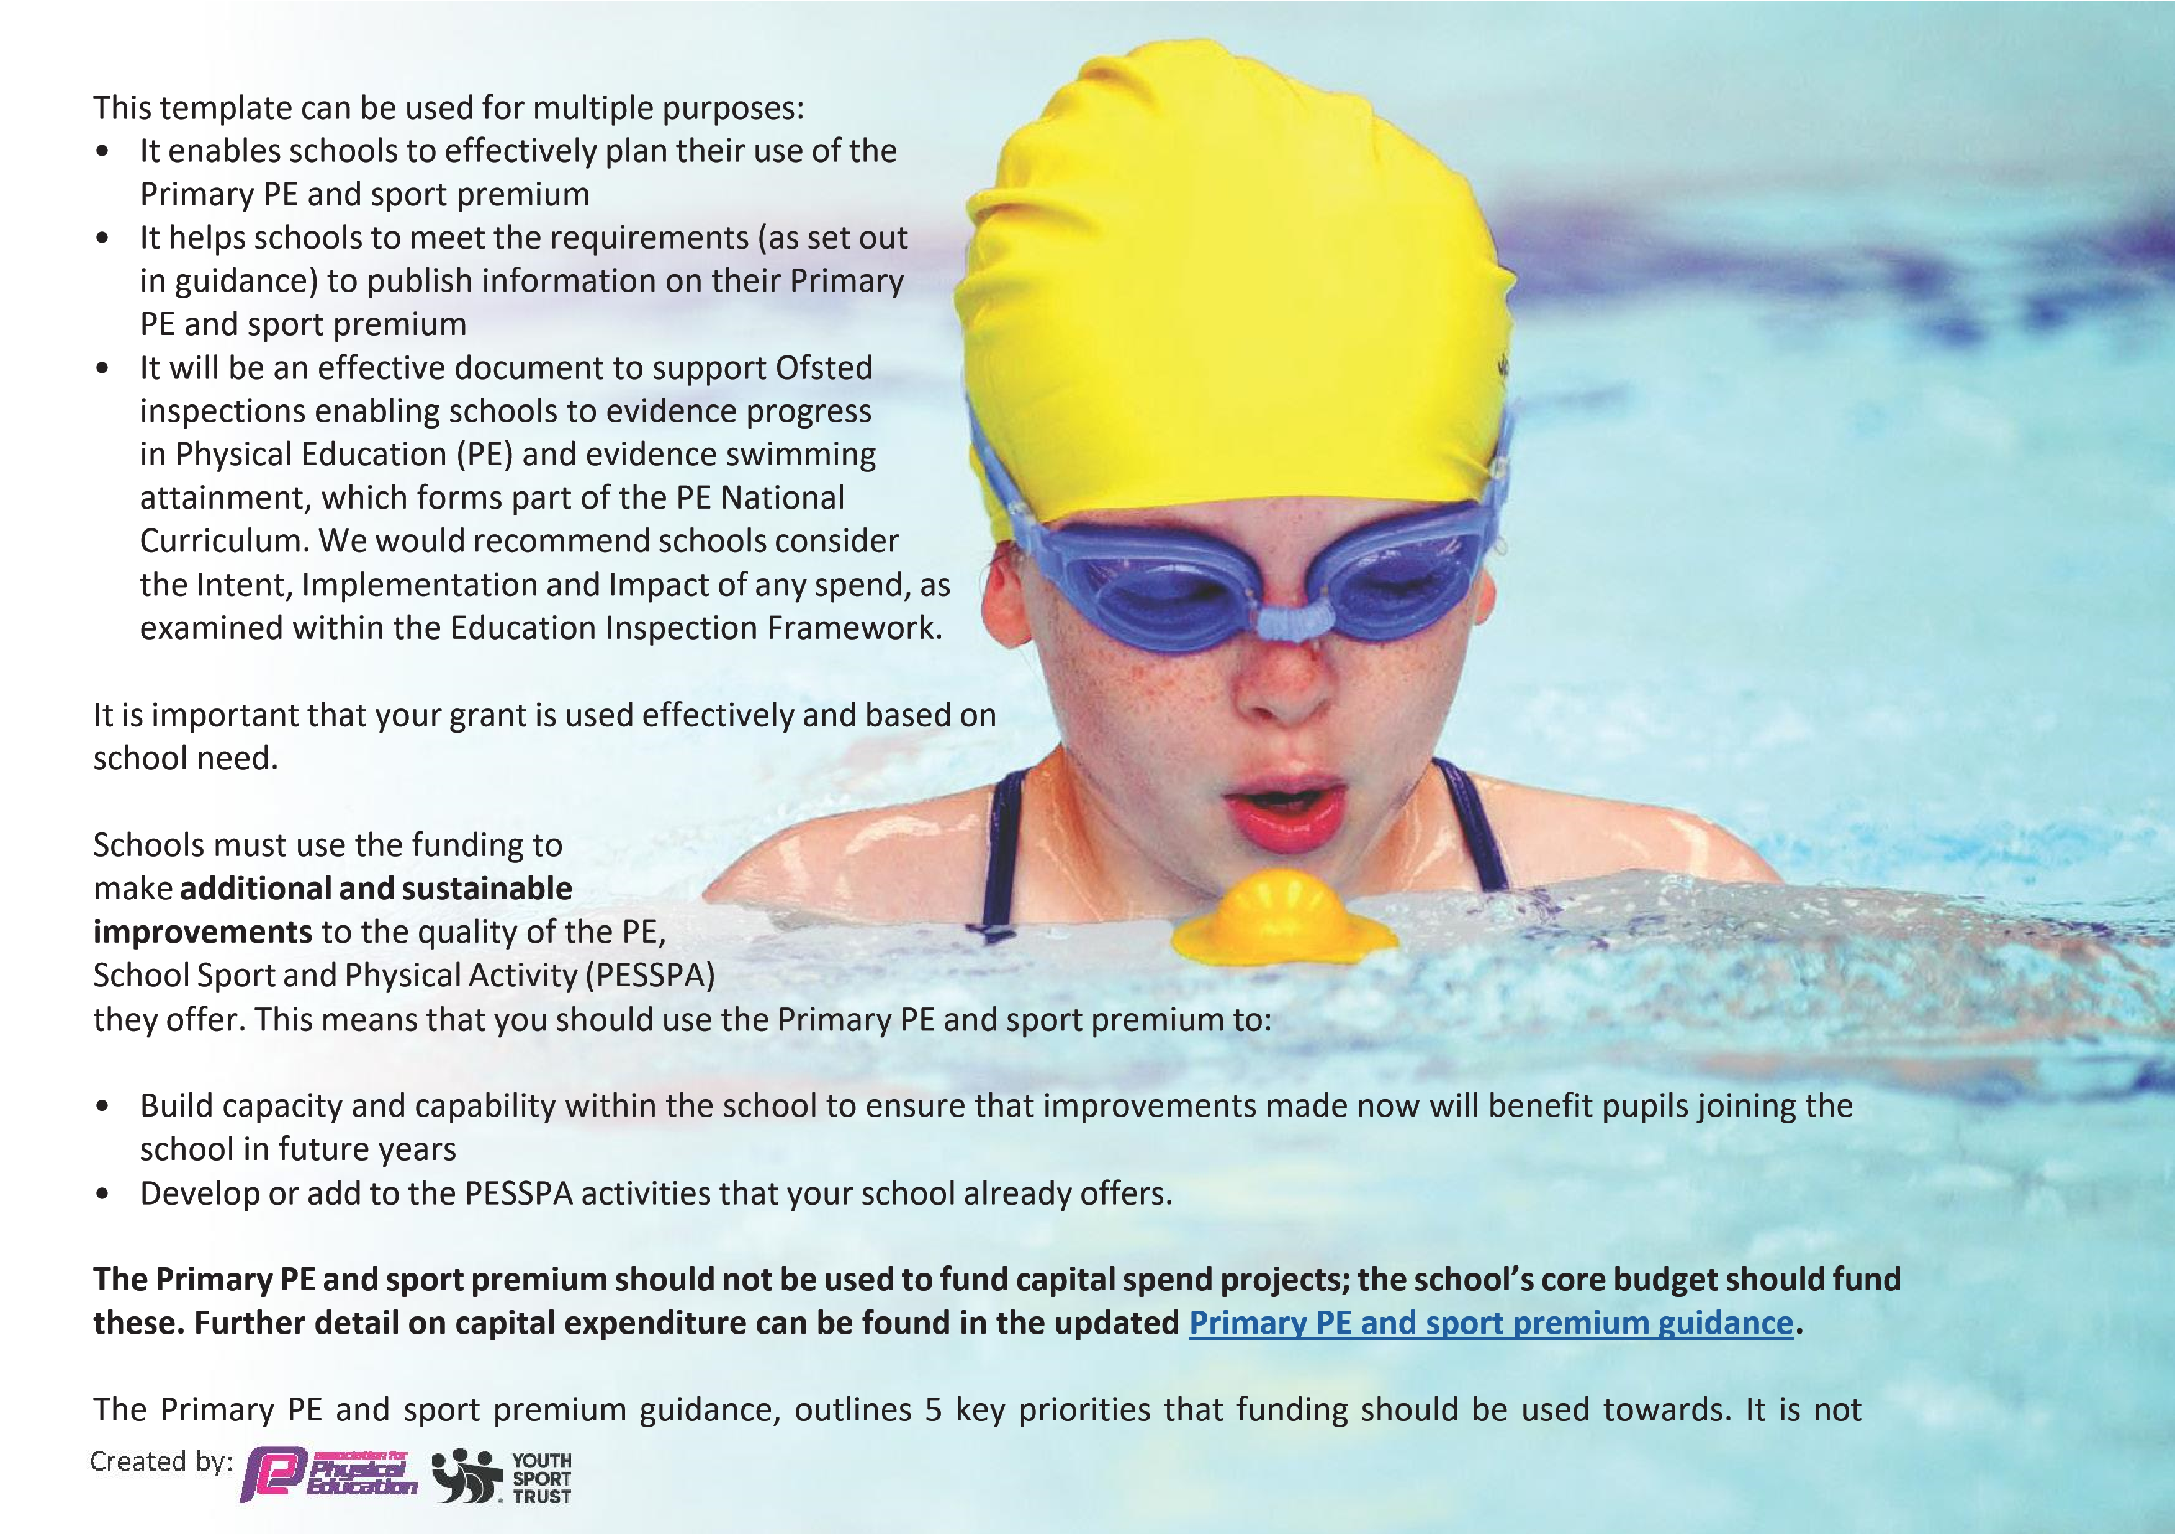
necessary that spending has to meet all the key priorities, you should select the priorities that you aim to use any funding towards.

Although completing this template is not a requirement for schools, schools are required to publish details of how they spend this funding. Schools must also outline what the impact this funding has had on pupils’ PE and sport participation and attainment and how any spending will be sustainable in the future. All funding must be spent by 31st July 2024.

Activity/Action | Impact | Comments
-Affiliation to local sports’ competition network through the Royal Latin School.  - Curriculum mapping for PE.  -Swimming lessons for year 5/6 pupils | - Children had opportunities to participate in competitive football tournaments in Year 3 -6  - PE curriculum reviewed to ensure breadth and balance and that all children accessed two hours of PE a week across a range of areas.  -75% of Year 6 pupils can swim 25 m in a variety of strokes with confidence. | - Children enjoyed the competitions and this raised the profile of competitive sport in the school.  - This has supported timetabling with the expanding of the school. Subject Monitoring confirmed that children accessed a broad and balanced PE curriculum with regular physical activity.  - We are moving core lessons to years 3 with year 4 as top up, to ensure that more pupils can achieve the required outcome.  - We have mixed aged classes and high levels of SEN, which requires additional adult support, leaving the rest of the school short-staffed during these sessions.

Review of last year’s spend and key achievements (2022/2023)

We recommend you start by reflecting on the impact of current provision and reviewing your previous spend.
-  -  -  -  - | New range of equipment for break and lunch time to support and enhance skills learnt in PE lessons.  High visibility jackets purchased to ensure safe walks around the village supporting more opportunities to move more during curriculum activities such as Geography and Science  Extra curricular clubs every morning offered by S4A. (Gymnastics, football and skittles  Progression of skills document developed to ensure that PE skills and knowledge are built upon sequentially and that children develop confidence, competence and experience throughout their time at Maids Moreton.  Replenishment of sports equipment for whole school and addition of sports equipment to enable full participation in a range of activities  Whole School Sports Day Autumn Term with the introduction of new activities. | - Children had a wider range of choices at break time to ensure they could more physically active.  -  - Children and staff were able to implement walks around the local area safely in a cross-curricular and meaningful way.  10% of children attended the morning clubs on offer from all year groups. Some of the children joined the same provider’s after school club as a direct result.  Progression of skills document provided useful guidance to staff on the hierarchical skills that children need to acquire and the sequence in which these should be taught.  New equipment purchased for gymnastics and games for EYFS, KS1 and KS 2  100% of pupils participated. Parents appreciated the events and the combination of competitive and non-competitive opportunities. | - | Children across all year groups have used the outdoor PE equipment. Observation at play times and pupil voice indicated that children regularly engaged with the new equipment.  -The pupils chose a walk as an activity for an end of term treat. Pupils reported the enjoyment of the walk and how it benefited the environment, in feedback sought.  -Children really enjoyed the clubs on offer and many attended specifically for interest, not solely for childcare reasons.  Staff felt more confident in the progression of skills for the different components of PE. The new equipment was well utilized in both curricular and extra-curricular time.  Pupils in UKS2 have enjoyed leading the whole school assembly on monitoring and managing the new equipment and look forward to being equipment monitors next year. Collab oration and co-operation has increased especially among LKS2 pupils.  Parents commented on how well the mixed house groups worked and how inclusive and supportive the children were. Every child loved the event and felt they had contributed to their team.


The assessment in PE is a priority as we make our curriculum development journey. We work closely with Sports4All providers to upskill staff and ensure that immediate support and assessment of skills and next steps is achieved for those requiring more support and those who are demonstrating higher levels of skill.

Healthy lifestyles and awareness of the positive impact on wellbeing and good mental health is an ongoing focus and whereas our site prohibits many of our pupils walking to school we offer opportunities for our pupils to implement walks around the local area to support first hand experiences in Geography, RE, Science and Art.

Key priorities and Planning 2023-2024

This planning template will allow schools to accurately plan their spending.

Action – what are you planning to do | Who does this action impact? | Key indicator to meet | Impacts and how  Sustainability will be achieved? | Cost linked to the action
Introduce lunchtime sports provision linked to S4A sports competitions  Affiliation to full  programme of events through the S4A/Royal Latin Sports Partnership | Teaching staff – to lead sessions  Pupils from KS2 to participate.  Teaching staff – organizing team and attending festivals  Pupils – attending festivals  Parents – transporting children to/from festivals | Key indicator 2 -The engagement of all pupils in regular physical activity  Key indicator 4: Broader experience of a range of sports and activities offered to all pupils.  Key Indicator 3: Raising the profile of PE and sport across the school.  Key indicator 4: Broader experience of a range of sports and activities offered to all pupils.  Key indicator 5: Increased participation in competitive sport. | More pupils meeting their daily physical activity goal  More pupils encouraged to take part in PE and Sport Activities and appreciate the benefits.  Children and parents attending sports festivals will raise profile of PE and sport.  Pupils will participate in a wider range of sports, including new and unfamiliar ones. | £3000  £1800

Affiliation to Aylesbury  Vale Athletics  Association  Dance workshops with  Dance school  Extra-curricular clubs offered by dance club | Teaching staff – organizing and attending events  Pupils – attending events  Parents – transporting children to/from events  Teaching staff – CPD to develop confidence and knowledge  Pupils – increased participation  Increase in uptake of pupils attending clubs | Key indicator 5: Increased participation in competitive sport.  Key Indicator 3: Raising the profile of PE and sport across the school.  Key Indicator 1: Increased confidence and knowledge and skills for staff  Key Indicator 4: Broader experiences for children  Key Indicator 2: Engagement of all pupils in regular physical activity  Key Indicator 3: Raising the profile of PE and sport across the school.  Key Indicator 4: Broader experiences for children  Key indicator 2 -The engagement of all pupils in regular physical activity | KS2 pupils to have the opportunity to participate in competitive sporting events and appreciate the enjoyment and team spirit.  Pupils to appreciate the benefits of dance. Staff to develop and improve their knowledge in dance and then be able to transfer to their own dance teaching in the future.  Pupils to appreciate the benefits of dance. Pupils to be signposted to dancing opportunities outside school. | £50  £950  None  £1900
Created by:

Line marking on field for track and field events.  Purchase new kit for inter school sports’ competitions enabling children to feel team identity and pride when competing.  Replenishment of sports equipment for addition of new school sports equipment for Upper Key Stage 2 to ensure children are able to access and utilise plentiful and high quality equipment. Purchase equipment required to participate in competitive sports, e.g. for football, netball, basketball, tag rugby, tennis, cricket, athletics. | Teachers-teaching PE  Pupils –participating in PE.  Pupils –representing the school in new kit.  Teachers –for teaching PE  Pupils – for participating in PE. | Key indicator 2 -The engagement of all pupils in regular physical activity  Key indicator 4: Broader experience of a range of sports and activities offered to all pupils.  Key Indicator 3: Raising the profile of PE and sport across the school.  Key indicator 5: Increased participation in competitive sport  Key Indicator 3: Raising the profile of PE and sport across the school.  Key indicator 2 -The engagement of all pupils in regular physical activity  Key indicator 4: Broader experience of a range of sports and activities offered to all pupils.  Key Indicator 3: Raising the profile of PE and sport across the school. | Lasting provision for the teaching and participation in field and track events  Children will feel pride in representing the school and belonging to the team.  Lasting provision for a wide range of new sports for children across the school. | £200  £500  £2500

Key achievements 2023-2024

This template will be completed at the end of the academic year and will showcase the key achievements schools have made with their Primary PE and sport premium spending.
Activity/Action | Impact | Comments
Sports4All P.E coaching  Spoorts4All before and after school activities  Participation in Royal Latin School sports events offer in partnership with Buckingham Primary School | Every pupil has access to sports coaches ensuring the delivery of high quality skills development and CPD for staff. A wide range of activities were offered and engagement was high in lessons.  Activities offered to those attending after school clubs, which are open to all pupils.  Year 3-6 were offered these events. | Staff and pupils engaged with the broad and rich activities offered. Staff confidence and competence in supporting pupils of all abilities.  Pupils reported high levels of engagement and enthusiasm in PE lessons.  This offer enhanced interest in activities in PE and provided a further opportunity to refine and rehearse fine and gross motor skill development.  The activities also promoted team work and communication skills between pupils of all ages across the school.  Transportation proved challenging, from the parent community and many could not provide transports very close to the events. The short notice meant we could not source appropriate transport to the events.
Created by:

New kit for inter school sports’ competitions purchased enabling children to feel team identity and pride when competing.  Replenishment of break time and lunch time equipment for whole school, to ensure children are able to access and utilise plentiful and high quality equipment and activities. Purchased equipment required to participate in competitive sports, e.g. for football, netball, basketball, tag rugby, tennis, cricket, athletics  Green planet forest school sessions secured for Reception to Key stage 1 pupils. | Children will be able to participate and represent the school in their new kit.  Children were able to practise and participate in new sports. Standards raised in games.  Pupils new to the school were able to collaborate and develop key skills, such as working safely, communication, problem solving and generating links with pupils outside of their class, ahead of moving up to mixed age classes. Awareness of the environment and their impact upon it was a key take away for our youngest pupils. | This gave children pride and a sense of team identity. This has had a really positive impact on the profile of sport within the school environment.  This gave children new opportunities to experience new sports, play competitively and work as a team. This has been very successful. In addition to the curricular offer, we have been able to run lunchtime clubs and competitions using the new equipment.  - Pupils LOVED these sessions. They asked to complete a litter pick and provide bee hotels, which they made. The sessions enhanced the fine and gross motor skills required for writing and loved how independent they had become and how much they could now do.

Swimming Data

What percentage of your current Year 6 cohort are able to perform safe self-rescue in different water-based situations? | 75% | There are only 4 pupils in this cohort.

Meeting National Curriculum requirements for swimming and water safety.
Priority should always be given to ensuring that pupils can perform safe self-rescue even if they do not fully meet the first two requirements of the National Curriculum programme of study

Question | Stats: | Further context  Relative to local challenges
What percentage of your current Year 6 cohort can swim competently, confidently and proficiently over a distance of at least 25 metres? | 75% | The poor attendance of one pupil meant that they missed lessons.
What percentage of your current Year 6 cohort can use a range of strokes effectively [for example, front crawl, backstroke, and breaststroke]? | 75% | Availability of pools close to our setting is very restricted and lessons are hard to secure.
If your schools swimming data is below national expectation, you can choose to use the Primary PE and sport premium to provide additional top-up sessions for those pupils that did not meet National Curriculum requirements after the completion of core lessons. Have you done this? | No | The one pupil who did not meet expectations, left the school in April 2024.
Have you provided CPD to improve the knowledge and confidence of staff to be able to teach swimming and water safety? | Yes | Staff involved with swimming given appropriate training and updates.

Head Teacher: | Sarah Prior
Subject Leader or the individual responsible for the Primary PE and sport premium: | Sarah Prior and Rob Small (Year 5/6 teacher)
Governor: | Amanda Hardman (Chair of Governors)
Date: | 28th July 2024
Signed off by:

