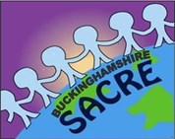


Buckinghamshire SACRE
Collective Worship SACRE Guidelines
2024-25

Whaddon C of E School

Date of policy: | September 2024
Edited by: | S Prior
Ratified by Governors: | December 2024
Review date: | September 2025

Contents
1.What are the legal requirements for collective worship? 2
2. What is collective worship? 3
3. The aims of collective worship 4
4. Wholly or mainly of a broadly Christian character 5
5. Writing a policy for collective worship 5
6. Practical matters: planning and organisation 6
7. What makes a good act of collective worship? 7

Schools may use this example as a basis for their policy if they wish. School policies must be ratified by the governors every time they are amended. Schools may find that some details which need to be amended more often than a policy is reviewed are better placed in an ‘appendix’ which does not need to be governor approved every time it changes.

The collective worship policy at Whaddon C of E School pays due regard to statutory requirements and has taken account of the guidance offered by the local authority through its SACRE. Collective worship is a valued and valuable part of school life and is taken seriously, as it shapes our approach to others and to what we do in school.

1.What are the legal requirements for collective worship?

The legal requirements for collective worship are laid down in the 1988 Education Reform Act and in the Collective Worship Circular 1/94 Collective_worship_in_schools.pdf (publishing.service.gov.uk) (1993 – 1994), which was an attempt to explain and enhance the 1988 Act. It states that collective worship: ‘Should aim to provide the opportunity for pupils to worship God, to consider spiritual and moral issues and to explore their own beliefs; to encourage participation and response, through listening to and joining in the worship offered; and to develop community spirit, promote a common ethos and shared values, and reinforce positive attitudes’.

The following bullet points give a concise summary of these requirements:

• All pupils in attendance at a maintained school shall take part in an act of collective worship each day. This can take place in groups at any time during the school day. Children under the age of five are not required to take part in an act of collective worship. Children in reception classes are required to take part in a daily act of collective worship. The law applies to all registered pupils, so this includes those over the age of sixteen in schools. The law applies to special schools as far as it is practicable. Maintained voluntary aided and controlled schools are also required to have a daily act of collective worship, however, its character and content is determined by the governing body.

• Collective worship shall be wholly or mainly of a broadly Christian character. This means it reflects the broad traditions of Christian belief without being distinctive of any Christian denomination. Across a term most acts of collective worship should be of this character, however not all individual acts of worship need to be of this nature. Further guidance is given on this requirement throughout this document.

• Collective worship should be appropriate to the ages, aptitudes, and family backgrounds of pupils

• The Standing Advisory Council on Religious Education (SACRE) may determine that it is not appropriate for a school to have collective worship of a wholly or mainly broadly Christian character. The headteacher of a maintained school may apply to SACRE for a determination after consultation with the governing body to consider whether it is appropriate for the requirement for Christian collective worship to apply in the case of their school. Further information can be sought from the SACRE advisor. SACRE | SchoolsWeb (buckscc.gov.uk)

• Parents have a right to withdraw their child(ren) from all or part of collective worship. Further guidance on the right to withdraw is given later in this document.

• Teachers should not be disqualified from employment or discriminated against in terms of pay or promotion on the grounds of their religious opinions or practice in participating or not participating in acts of worship. This applies to all teachers except those in voluntary aided schools and some in voluntary controlled schools. It is a teacher’s duty to attend assemblies, but they are not required to lead the collective worship part of this occasion. It is hoped that this document outlines a fully inclusive approach to collective worship within the realms of the law which all teachers will feel able to attend.

2. What is collective worship?

• Nature of collective worship in schools ‘Worship’ is not defined in the Education Act. This guidance therefore draws on the DFE circular 1/94 for clarification. This states that: ‘worship must in some sense reflect something special or separate from ordinary school activities and it should be concerned with reverence or veneration paid to a divine being or power… worship in schools will necessarily be of a different character from worship amongst a group with beliefs in common.’ It is not possible to compel people to worship, but we can provide opportunities for it to happen and enable pupils to respond reflectively. As collective worship takes place in schools, its primary function is an educational one, that is to promote spiritual, moral, social, and cultural (SMSC) as well as intellectual development. Considering this, collective worship should be a) active, rather than passive (e.g., children are actively involved in answering questions) b) directed towards something (e.g., a value/someone) c) personal (e.g., time for reflection and response to God if appropriate).

• Collective worship and religious education (RE) Collective worship and RE are separate areas of school life. The legal requirements for RE and collective worship are distinct and should not be confused. Schools should have separate policies for RE and collective worship. Schools should not assume that the RE coordinator is responsible for collective worship; this should be a matter of negotiation. The only part of the law which is similar for both areas is that of withdrawal. All other areas including time, the Christian character of collective worship and determinations DO NOT apply to RE. Nevertheless, there may be opportunities for children to use their RE work in collective worship or for collective worship to reinforce the learning taking place in RE e.g., at times of religious festivals.

• Collective worship and assembly Collective worship and assembly are distinct activities, although they may take place as part of the same gathering. Collective worship is a special time for pupils to reflect upon life experiences and ultimate questions and, if appropriate, focus on God. It should allow the pupils to be able to make a spiritual response. A model combining the ‘assembly’ and ‘collective worship’ aspects can be found in section seven. An assembly is a gathering of part or all the school. It is concerned with administrative matters and other announcements about school life. Schools often gather for achievement assemblies, singing assemblies and curriculum assemblies. These can be made into an act of collective worship through the addition of an opportunity for reflection or prayer at the end of these times. Without it they stay as an assembly.

• Collective worship and fundamental British values Collective worship makes an important contribution to developing pupils’ understanding of fundamental British values as defined by Ofsted. Effective SMSC development can support pupils in better understanding and applying these fundamental British values.

• Responsibilities for collective worship It is the shared statutory responsibility of the headteacher and governors to ensure there is appropriate provision for collective worship.

3. The aims of collective worship

This lists below are not exhaustive; however, they show how collective worship can contribute to SMSC and the intellectual development of pupils. Schools may wish to use these lists as a starting point to reflect on their own practice in this area.

Spiritual development
• Do the pupils have an opportunity to experience worship of God, if appropriate?
• Are feelings such as awe, wonder, thankfulness, mystery, and joy evoked through collective worship?
• In what ways can pupils respond to the aesthetic e.g., music, poetry, art, literature?
• How do pupils explore a sense of the sacred?
• Do pupils explore their place in the world and their search for meaning?
• Are pupils given an opportunity for reflection and contemplation?
• Are pupils asked ultimate questions?

Moral development
• How do we encourage respect for others and care for the environment?
• Do pupils understand the importance of commitment in human living?
• How far can pupils foster the virtue of fairmindedness and a willingness to consider the views and values of others?
• In what ways do we help pupils understand the balance between rights and responsibilities?
• How do we help pupils make informed moral choices?

Social development
• How do we develop the school as an inclusive community through collective worship?
• How do we promote a feeling of community, with a shared ethos and values?
• How do we provide an opportunity for pupils to become acquainted with school governors and other community leaders?
• In what ways do we celebrate gifts, talents, and achievements through collective worship? • Do pupils know a sense of belonging through collective worship?

Cultural development
• How does collective worship reflect the school as a diverse community?
• Do we provide an opportunity for pupils to become acquainted with local leaders, including religious ones? • How do we celebrate cultural and religious festivals?
• Do we give opportunities for pupils to consider the dynamic nature of culture and how it impacts on society?

Intellectual development
Do our pupils have opportunities to:
• Empathise with others?
• Interpret beliefs, symbols, stories, and poetry?
• Apply insights gained into daily life?
• Analyse beliefs and evidence?
• Evaluate ideas and values and make links between them?

4. Wholly or mainly of a broadly Christian character

This statement means that collective worship must reflect the broad traditions of Christian belief. It does not mean that all acts of collective worship should contain only Christian material. Across a term, most of the acts of collective worship should be wholly or mainly of a broadly Christian character.

There are religious and human values that many religions and life stances (e.g., Humanism) have in common, e.g., justice, love, peace, charity, sacrifice, morality, saying sorry. Worship with a theme such as ‘forgiveness’ or ‘honesty’ is broadly Christian even if specific Christian material is not used.

Many Christian beliefs are shared by other world religions e.g., God as creator, humankind as stewards of the world, goodness overcoming evil. For example, the Jewish festival of Hanukkah celebrates freedom from oppression and the power of God. In collective worship, material based on this celebration would allow those who believe in justice to share and be broadly Christian too.

Just over half the acts of collective worship need to be broadly Christian. Therefore, a significant minority can be broadly of the character of other world religions.

Specific Christian beliefs should not be ignored, e.g., Jesus as the son of God. The major Christian festivals will give the school an opportunity to reflect on these specific Christian beliefs. Schools may make use of Christian visitors to contribute to this element of the law.
By using these principles, it is possible to provide collective worship of a broadly Christian character in a school where a large majority of students have a faith other than Christianity or have no faith.

5. Writing a policy for collective worship

Every school should have a policy on collective worship which is regularly reviewed and updated. This policy should include:
• The legal requirements e.g., the Education Act, the distinction between assembly and collective worship, the distinction between RE and collective worship, if the school has a determination this should be clearly stated
• The aims of collective worship in the school e.g., reference to school ethos or mission statement, reference to SMSC and intellectual development
• How collective worship is organised e.g., time of day, year groups, teacher responsibilities. This could be done as a chart for example.
• The use and role of visitors e.g., guidelines for inviting in guests, names of people who frequently lead acts of collective worship
• Collective worship and inclusivity e.g., meeting the needs of different ages, abilities, and backgrounds
• Collective worship and the right to withdraw e.g., parents’/carers’ right to withdraw, statement about the process for this to happen e.g., meeting with the headteacher
• Evaluation and monitoring of collective worship e.g., how collective worship is evaluated and monitored, how frequently this takes place

6. Practical matters: planning and organisation

The systematic planning of collective worship is essential if a school is to ensure that the legal requirements are being met, i.e., that across a term the acts of collective worship are wholly or mainly of a broadly Christian character.

Who should plan it? This is at the discretion of the school. The post holder responsible for acts of collective worship is normally the person who creates long and medium-term plans for the delivery of collective worship. However, the following are also acceptable:
• Holding a staff meeting to agree long term plans
• Basing plans on school assembly files

Long term (termly) planning best practice is evident when schools have a systematic approach to the use of themes in collective worship.

• Theme for the week
Themes for a whole term are devised at the end of the previous term using festival dates, notable events, and other publications to create a theme for each week. Best practice sees this developed so that there is a quotation or thought publicised around the school to go with the theme.
• Theme for each month/half term This allows for an in-depth exploration of a wider theme, e.g., the natural world. It may be interspersed with the celebration of festivals and other important occasions. It should be made clear in each week which aspect of the theme is being looked at.

Medium term (weekly) planning
Best practice is evident when the post holder has clearly indicated which story or input is to be used each day. The most effective practice also provides the resources with the weekly planning sheet for teachers who are leading collective worship or indicates clearly where resources can be found (e.g., books and page numbers are stated).

Short term (daily) planning
If the long- and medium-term planning is in place, then the short-term planning will become much easier. It is suggested that teachers record their own acts of collective worship. These can be used for evaluation and monitoring purposes, as well as filing them for other teachers to use in the future.

Organising collective worship
The legal requirements state that all pupils should have a daily act of collective worship. In many schools this is difficult because of a lack of suitable spaces. The following are suggestions to help schools meet the requirement in difficult circumstances:
• If the school has a public address system it could be used daily to share a short reflective passage
• The school could set aside five minutes each day for a short reflective time or moment. A different focus could be given to colleagues each week or day through the school bulletin or briefing, e.g., a theme or quotation could be read out and pupils given a moment to pause and think about it.
• The school could organise collective worship in small groups, e.g., tutor groups, in secondary schools. Pupils can lead classroom-based collective worship.

7. What makes a good act of collective worship?

An effective practice model for an act of collective worship This format is based on one produced by Blackburn Diocese but is appropriate for use in non-denominational schools.

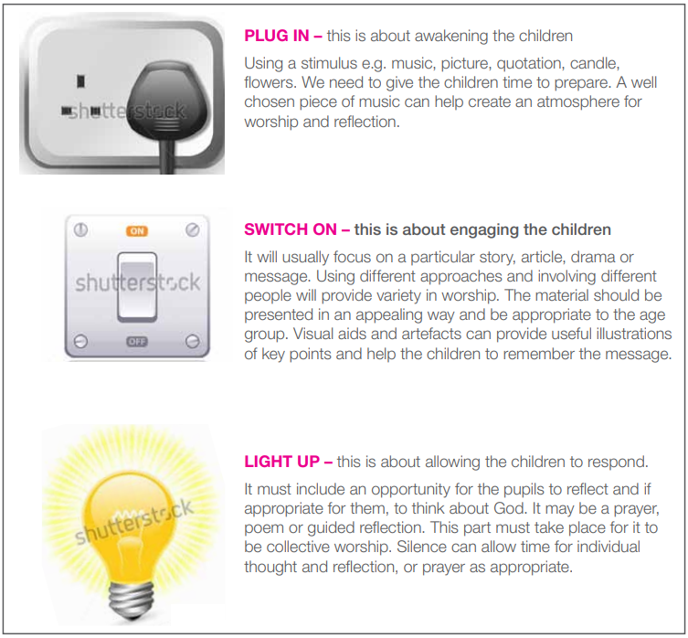

Note: It is common for schools to combine an assembly and collective worship. In this case, the ‘Plug in’ and ‘Switch on’ parts may be regarded as part of the assembly. The act of collective worship is the ‘Light up’ aspect.

