Hedgehog Class Weekly Update Week Beg: 27th March

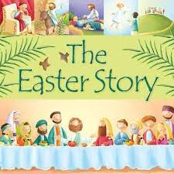
Language and Literacy
Our last week of the term focussed on the Easter story. Taking part in the drama in the church celebration helped us understand this important story for Christians. Year 1 did some reading comprehension abut Easter traditions. We all wrote messages for the fabulous cards made for our families.

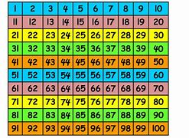
Maths
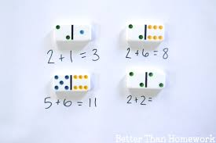
Year 1 have been using 2 digit numbers, remembering which digit shows tens and ones. They also found the number that is 1 more or less than another using a 100 square. They have begun seeing patterns that go across and down this special arrangement of numbers. Reception have been combining groups of objects as they begin addition. They used dominoes to find 2 groups then find the whole amount of dots by counting them altogether.
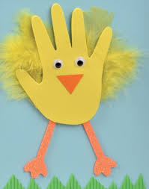
Art / Design
We have enjoyed making some Easter cards using collage and paint techniques to represent chickens! It was great to see children making their own deign choices and working independently to achieve the results they wanted. They have also decorated some super wooden spring animal shapes. Your homes will look very Spring-like and colourful!
Easter Extravaganza!
We had a fantastic fun-filled time on Thursday, hunting all around the school grounds for coloured balls. Playing in our House Teams, we dashed about and successfully reached the target number to exchange them for Easter Eggs. Thanks to Friends of Whaddon for their kind donation of these treats!

RE | Music, Drama & Movement
We have listening to the sequence of bible stories which is told at Easter through Holy Week.  We heard and reflected on the story of Good Friday, when Jesus died on cross. However, we learned that this is not the end of the story as on Easter Sunday, Christians celebrate that Jesus came back to life! | Thank you to the families that came to join us at church on Friday; we hope you enjoyed sharing in the Easter Celebration  The children sang and acted beautifully in our service which truly celebrated the joy of Spring and brought the meaning of this special bible story to life.
Next Week
Enjoy the Easter Break! There are some Phonic, Handwriting and Maths sheets in bookbags should you wish to support the children with some work over the holidays. House Points available for completed work!
Remember: The School Day starts at 8.30am from Monday 17th April.

