Hedgehog Class Weekly Update Week Beg: 15th May

Forest School is on Wednesday afternoons for Hedgehog class.
Please make sure children have sunhats and water bottles as well as wellies and waterproofs for their sessions – the weather is very changeable!!

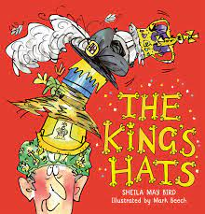
Language and Literacy
Returning to our Once Upon a Time theme, we have been reading and writing around the Jack and the Beanstalk story. We have explored some unusual retellings of this traditional tale (for example Jim & the Beanstalk by Raymond Briggs and Jack & the Baked Beanstalk by Colin Stimpson) and talked abou the what is similar and different to the original version. Writing letters to the giant and Wanted posters have added to our understanding of the characters.

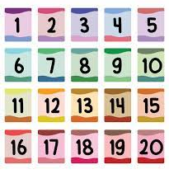
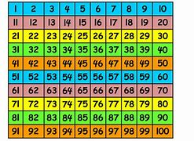
Maths
Year 1 have used 2 digit numbers on a hundred square. They have found money totals using number bonds to 20 and added 11 and 12 to numbers. Reception continue practising reading and writing numbers up to 20; this week we have been estimating sets of objects and thinking about whether amounts are more, less or the same as numbers from 10-20.
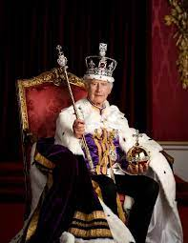
History
We completed our work on our Royal family by learning more about their family tree and seeing who our next monarchs will be. Year 1 completed their own King Charles fact files. We also looked a pictures and looked at longer timelines/dates from the past to find out who Charles I and Charles II were and when they lived.
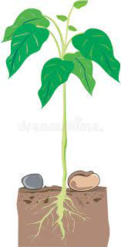
Science
During our outdoor learning this week we were keen to see how our bean plants are growing. We also planted some seeds directly in the soil to see if they will also grow into strong, healthy plants. It will be interesting to investigate if what is the same/different.
RE | PE
We have been learning about Jesus as a leader and what made people want to follow him in Bible times, then what makes Christians continue to follow Him now. | We have started work on Ball Skills.  Working in pairs and small teams, we will send and stop a ball to one another and also into targets/goals.
Next Week
Literacy/Language Reading and writing about Castles
Phonics Year 1: Alternative Pronounciations: y (as in fly) ow (as in snow) g (gem) / ph
Reception: Phase 3 consonant diagraphs oo (in moon) oo (in book) / ar / or
Maths Year 1: Count in 10s, add and subtract 10 or 11, money problem solving Reception: Use numbers to 20, adding and taking away in games/sorting activities
Art / Design Making our own model castles, Designing flags and coats of arms
History Learning about how and why castles were built

