Hedgehog Class Weekly Update Weeks Beg: 1st/8th May

Come to the May Fayre on Sunday: we are dancing for you!!
Check ParentMail for details on where to meet, what to wear and
how we will raise money for our school together.
Forest School is on Wednesday afternoons for Hedgehog class.


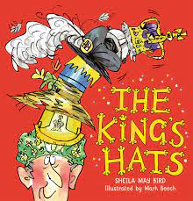
Language and Literacy
We have been inspired by the recent Coronation to talk, read and write about all things Royal! We read a story called The King’s Hats which helped us think about how it would feel to be monarch. Using our imaginations further we pretended then wrote about being King or Queen for s Day; what we would wear, where we would live, what food we would be served and what we might ask our people/servants to do! There were some brilliant ideas about how we might make a country a happy and kind place to be.
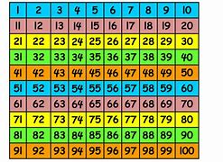
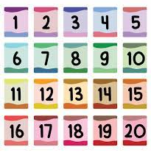
Maths
Year 1 continue using 2 digit numbers on a hundred square. They worked on various calculations including money problems by counting forward and backward in multiples of 10. Missing numbers in sequences from the 100 square made for a tricky challenge! Reception have been practising reading and writing numbers up to 20; completing sequences and finding missing numbers.
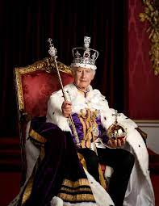
History
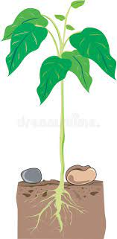
Having celebrated the Coronation of King Charles III, we have been learning about the meaning of the ceremony including looking at what was the same and different to his mother. Queen Elizabeth II’s day. We looked at significant events in the King’s life by placing photos on a timeline and found out more about the British Royal Family on their family tree.
Science
During our outdoor learning this week we were excited to see our bean plants shooting up and have now put them into the vegetable plot at Forest School! We need to keep observing their growth and change. We have not needed to water them this week though.
RE | Music & Dance
We have been thinking about the role of our country’s leaders, especially King Charles.  We have been remembering him in both our class and school collective worship times. | We are learning traditional folk dances to perform at the May Fair. Working with partners and remembering different movement sequences is great for physical and brain development!
Next Week
Literacy/Language Reading and writing about
Phonics Year 1: Alternative Pronounciations: y (as in funny) ea (as in head) wh / oe
Reception: Phase 3 consonant diagraphs oo (in moon) oo (in book) / ar / or
Maths Year 1: Count in 10s, add and subtract 10 or 11, money problem solving Reception: Use numbers to 20, adding and taking away in shop/money activities
Art / Design Making objects for castle life and Royal Celebrations
History Learning about the life of King Charles and the Royal Family

