Hedgehog Class Weekly Update Week Beg: 17th April

Language and Literacy
We began with talking about then writing recounts of our own Holiday News events. Reception wrote simple sentences – they have all shown how well they use sounds to spell words now, with their letter formation also improving. Year 1 independently wrote sequences of sentences describing what they did, where they went, who with and how they felt. Their spelling and punctuation shows increased accuracy each half-term when we do this. We have also begun a short unit on the traditional tale of Jack and the Beanstalk.

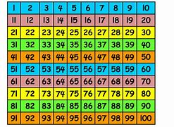
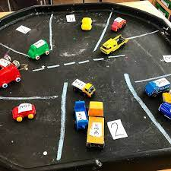
Maths
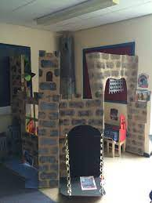
Year 1 have been using 2 digit numbers on a hundred square. They found the number that is 10 more or less, then counted on in multiples of 10. Reception have been finding the number that is 1 less than another using numbers to 10 or 20 using objects such as cookies on a plate and cars in a car park. Everyone is working hard at ordering and writing numbers accurately – Reception with numbers to 20 and Year 1 in sequences of 10s numbers.
Art & Design
We illustrated our Easter Writing with careful drawings. We then returned to our Once Upon a Time theme by continuing to build and furnish our role play castle area in the classroom. We will continue adding to this as the Kings coronation celebrations approaches.
Science
Forest School gave children the opportunity to predict what would happen when popcorn kernels were heated. It was quite a surprise to see them change in colour, shape and size (and yummy to eat too!). Some of the bulbs and seeds planted last term have begun to show shoots – have any of the Mothers Day bulbs started to grow yet?
RE | Music & Dance
We thought about what we are grateful for, thinking about what Gods blessings are to us.  We had times of quiet reflection and some children chose to say their own prayers aloud. | We have begun learning traditional folk dances to perform at the May Fair. Working with partners and remembering different movement sequences is great for physical and brain development!

Next Week
Literacy/Language based on Jack & the Beanstalk including retelling and character descriptions
Phonics Year 1: Phase 5 split digraphs a_e / o_e / i_e / e_e / u_e
Reception: Phase 3 consonant diagraphs ai / ee / oa / igh
Maths Year 1: Count in 10s on 100 square, adding on in 10s
Reception: Revise numbers to 20, Practical subtraction activities
Art / Design Creating beanstalks and Making objects for castle life
Science Learning about what plants need to grow and predictions for growth

