Hedgehog Class Weekly Update Week Beg: 6th March

We really enjoyed our visit to the theatre for the musical performance of a story. The opportunity to hear and interact with musicians playing live was a brilliant experience for the children and they joined in with great enthusiasm. Thank you for your contributions to make it happen!
Please check your emails for messages about Comic Relief Fundraising Day / Mothers Day Event coming up next week
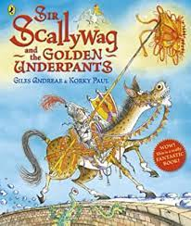
Language and Literacy
Sir Scallywag and the Golden Underpants, about a young, brave knight who saves the day by finding a Kings lost underwear, is a fantastically funny rhyming story. We have loved discussing the words and events; thinking about what is the same and different about this and other traditional tales that we know. Year 1 did some reading comprehension based on the story of Rapunzel. We also wrote some Goodbye and Thank You messages to add to a leaving card for Mrs Gyau-Awuah.

Maths
We have been learning about Time. Reception have been sequencing and talking about the events of a school day, using words such as first, next, later, morning, evening and night. They have begun learning the order of the days of the week. Year 1 have been reading and writing down o clock and half-past times on both clock faces and digital times. They have talked about how the hands move and by how many minute through the hours of a day. Making our own clocks/watches and adding the hands helped us understand how the numbers/hands tell us the time.
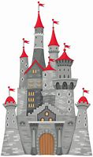
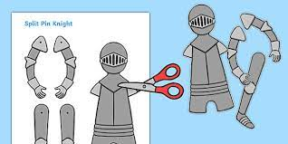
History / Design Technology
Our topic leads us into learning about ‘Long, Long Ago’ and our story has started our thinking about how people may have lived in Castles in the past. We learnt about the different parts of a castle and have begun creating our own royal role play area! We also using junk modelling and block resources to make small world ones. Along with this, we made some split pin knights to add fun to the scenes!

RE / PSED | PE & Music
We have been thinking about special people and be thankful for how they help us.  We made a card and wrote messages for Mrs Gyau-Awuah who we will miss very much.  And beginning some work on thanking some special people at home too – more to be revealed very soon! | We did a Singing/Yoga session based on Frozen  (very appropriate on a snowy day!)  using our balance and strength to hold the various poses throughout the story.  We had an amazing experience at the show hearing a flute, oboe, French horn, double bass, cello and piano played. Our singing sounded incredible with several other schools!

Next Week (we will consolidate this weeks learning due to timetable changes over 2 weeks)
Literacy/Language Activities based on Sir Scallyway & the Deadly Dragon Poo
Phonics Year 1: Phase 5 digraphs: oy / ir / ue / aw continued
Tricky Words: Mr Mrs looked called asked
Reception: Phase 3 digraphs: sh / ch / th / ng (spelling)
Tricky Words: he / she / me / we / the
Maths Year 1: Know days of week/months of year, Read o’clock & half past times
Reception: Using the language of time, Sequencing daily/weekly events
Art / D.T. Top secret projects to prepare for thanking some special people...

