Hedgehog Class Weekly Update Week Beg: 30th January

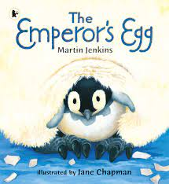
Language and Literacy
We read ‘Lost and Found’ by Oliver Jeffers together, enjoying the tale of friendship and travelling together. It also led to lots of other learning about penguins and places. We also learnt read the fact-based book The Emperor’s Egg which helped us understand more about these amazing birds. Year 1 learned lots of fascinating penguin facts and created brilliant fact files. Reception have been using their phonics to write their own minibooks with short sentences. It’s wonderful to see everyone’s writing improving week by week!
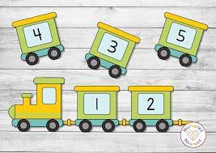
Maths
We returned to numberwork this week. Year 1 have been working hard at understanding that Numbers from 10 to 20 are made up of Tens and Ones, by using sticks of cubes, writing sums starting with 10+ and checking we have written these numbers correctly. Reception have been busy reading and ordering the numbers to 10, as well as carefully counting the sets of objects to go with them – it would be great if these children could keep looking out for numbers 0-10 at home and when they are out and about too.
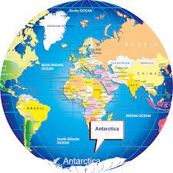
Science / Geography
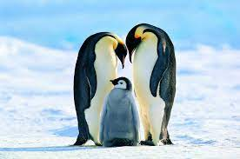
We have been fascinated to find out lots of information about Penguins. We have discovered the different ways they move, how the eggs are cared for and hatched, what the chicks and adults eat and whereabouts they live. We found the home of Emperor Penguins on a globe. I challenge the Hedgehogs to share their brilliant penguin knowledge with families! Year 1 continued their learning about Where We Live by creating mini-books showing our home in it’s village/town, county, country, continent and world.

RE | PE | Music
We have started a unit of work about Creation.  We learned about the different Days of God’s Creation from the Bible Story and did different activities to help us recall the sequence. | We did a Dance session inspired by Penguins; exploring the shapes and travel types/directions inspired by real penguins on videos.  Please note:  ALL of Hedgehog Class will now do PE on THURSDAYS, please send your child in suitable sports clothing. | Reception have been copying musical patterns and following the beat to songs using percussion instruments. They also added their own verses to familiar songs  Year 1 have developed their singing skills with Ms McKee, focussing on a different speech sound each week.
Please also note that ALL of Hedgehog Class now do FOREST SCHOOL on FRIDAYS
Next Week’s Learning:
Phonics: Year 1 – Reading and Writing Phase 3 trigraphs air / ure in sentences and stories
Reception – Practising Phase 3 single sounds w / x / y / z / qu by writing words
Maths: Year 1 – Using numbers to 20, introducing place value (understanding 10s and 1s)
Reception - Using numbers, matching and comparing amounts up to 10
Geography – Locating Polar regions of the world, comparing to the UK
Science, Art and Design – Creating penguins and model boats to be tested in a water tray
Language/Literacy: Reading and Writing activities based Penguin Small by Mick Inkpen

